Injection Series Part 3

a. How many arguments does the sample take?

Ans – 1

If we take a close look at the de-compiled sample there are 2 arguments “message” and “killall” in FUN_00401000.
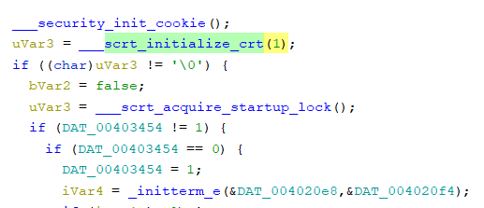

Initializing program with 1 argument as highlighted above.

b. Again, what is the size of the shellcode? 😉

Ans – 288 bytes

In the FUN_00401000 there are memory allocations which clearly indicates the presence of shell code.
If we take a closer look at the VirtualAlloc function (VirtualAlloc function (memoryapi.h) - Win32 apps | Microsoft Learn ) we can see the start and the end address (0x0 and 0x120) which translates to (0-288).

To confirm our observation we can see the memmove() function which moves a chunk of data of size 0x120 (288).
(memmove() in C/C++ - GeeksforGeeks)

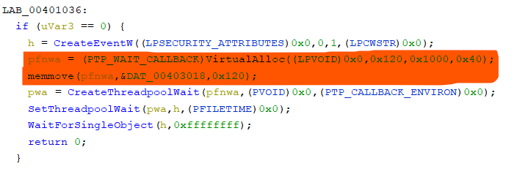

c. In VirtualAlloc what does the flAllocationType value represents?

Ans – MEM_COMMIT (0x1000)

VirtualAlloc function (memoryapi.h) - Win32 apps | Microsoft Learn

d. What is the argument required by the sample to run the shellcode?

Ans – message

If we read through the highlighted portion of the code below we can see the variable with the value message is initialized.
The program is trying to validate conditions (checking the argument) and jump to LAB_00401036, where the memory is allocated to the shell code using VirtualAlloc() function.
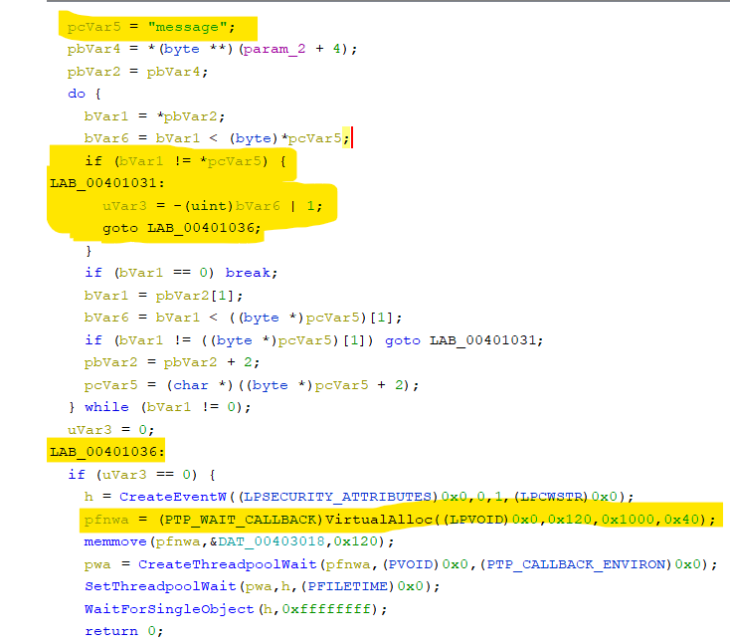

e. What is the payload in Metasploit that would have been used to generate the shellcode?

Ans – payload/windows/messagebox

When the sample is run with “message” argument as discussed above the following happens.

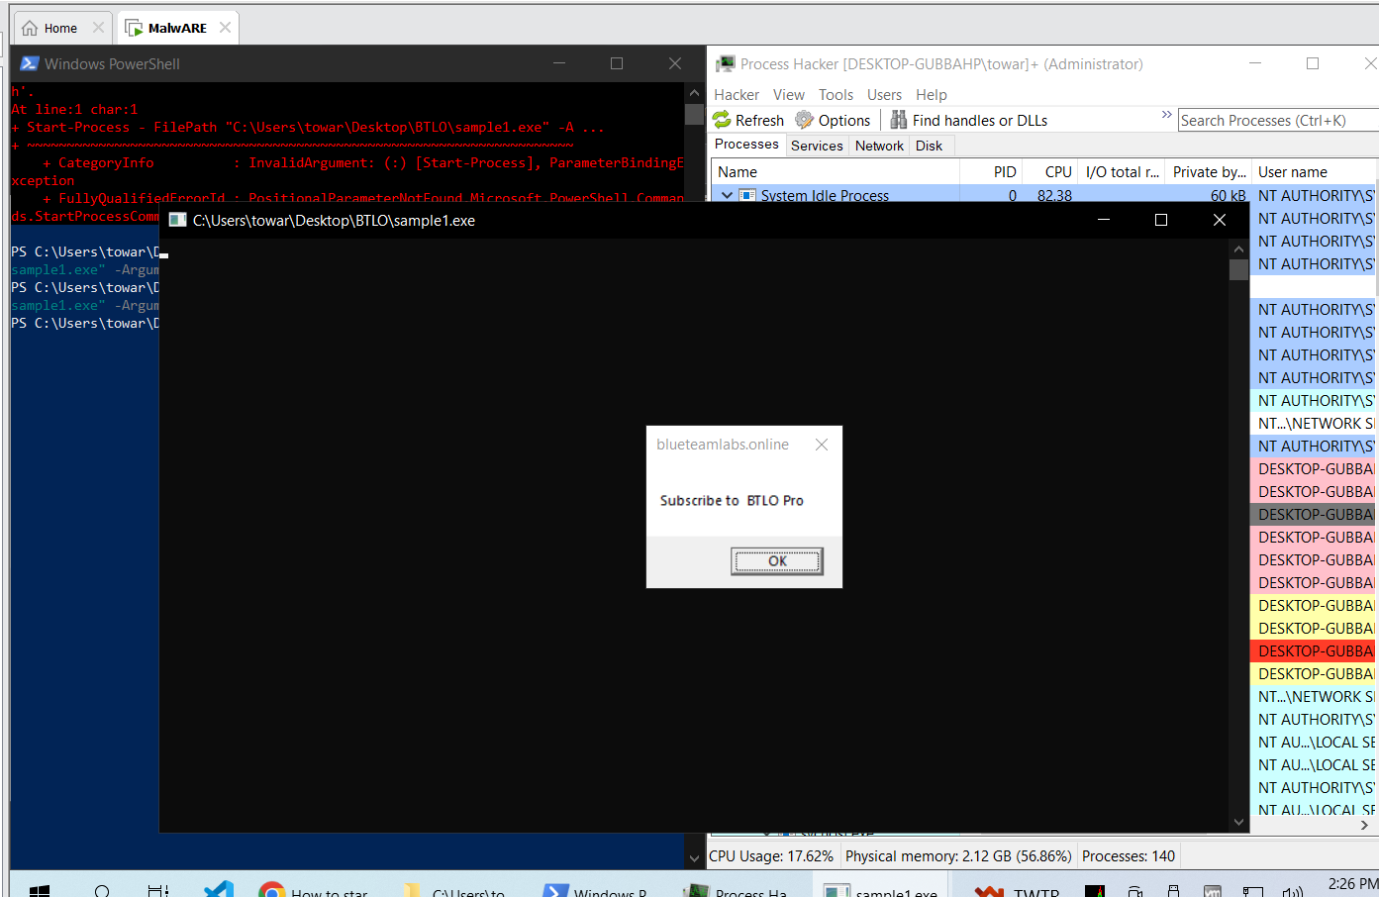

The following pop-up appears when we run the sample with “message” argument.
Start-Process -FilePath "C:\Users\towar\Desktop\BTLO\sample1.exe" -ArgumentList 'message'

f. What is the API used to create a wait object?

Ans – WaitForSingleObject

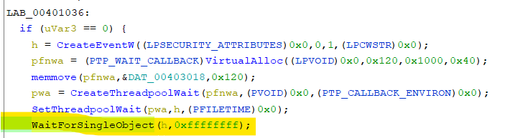
WaitForSingleObject function (synchapi.h) - Win32 apps | Microsoft Learn

g. What is the library function used to copy shellcode between memory blocks?

Ans – memove

Discussed in detail in question b.

h. What argument to the sample invokes powershell process?

Ans – killall
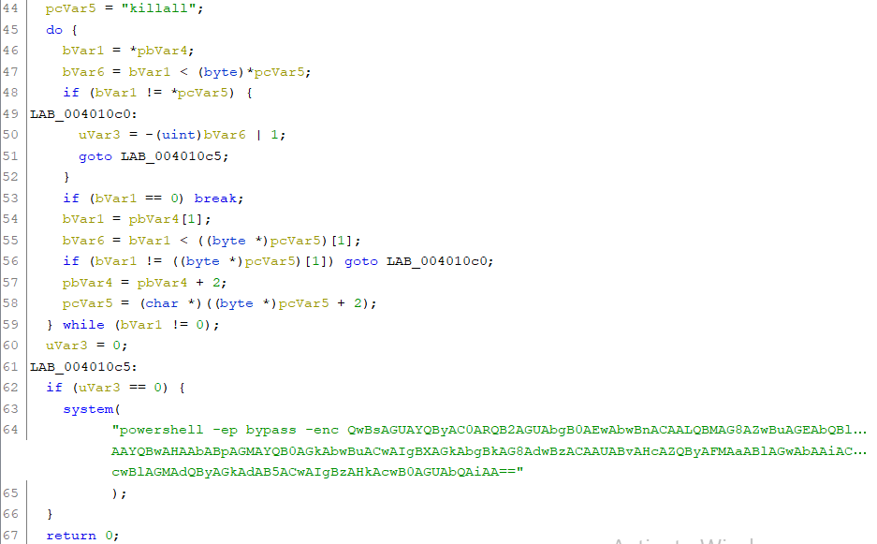

Explanation is same as question d.

i. After decoding the powershell, list the log names as in the order in the script ?

Ans. Application, security, system

On decoding the base64 power-shell command line we get the following:-

Clear-EventLog -Logname application,"Win￹dows PowerShell",security,"system"

So in layman terms the above translates to
“clear security events from the event log for windows powershell application”

